A Report
On
A Workshop
On
UGC
Scheme for Trans-disciplinary Research for India’s Developing Economy (STRIDE)

Organized by
Internal Quality Assurance Cell (IQAC)
Vidya Vikas Mandal’s
Sitaram Govind Patil Arts, Science and Commerce College, Sakri (Dhule)

- Name of the workshops/seminars: UGC Scheme for
Trans-disciplinary Research for India’s Developing Economy (STRIDE)
- Number of participants: 30
- Date : 13/08/2019
- Preamble: A workshop on UGC Scheme for Trans-disciplinary Research for India’s Developing Economy (STRIDE) has been conducted on 13th August, 2019 at Vidya Vikas Mandal’s Sitaram Govind Patil Arts, Science and Commerce College, Sakri organized Internal Quality Assurance Cell (IQAC) in order to fulfill the objectives as follows-
- To introduce UGC STRIDE Scheme to promote the quality research among faculty members
- To convey the aims of STRIDE to the faculty members
- To encourage faculty members to undertake research projects
- To promote institutional research culture
- Participant’s Profile: A total of 08 delegates from 02 colleges of the surrounding area and 22 faculty members from the Host College participated. Among the participants, 04 faculty members were from Karm. A.M.Patil College, Pimpalner and 04 faculty members were from U.P.College, Dahiwel. 22 teachers of S.G.Patil College actively participated in the workshop.
- Business of the Workshop
13th August 2019 (Tuesday)
- Inauguration of the Workshop:
On the inaugural function, Hon. Prin. Dr.R.R.Ahire inaugurated the workshop by enlightening the lamp. Dr. Anant B. Patil (Vice-Principal), Dr Sachin Nandre, Dr. N.H.Aher, Dr. V.B.Bachchhao and Dr Dnyaneshwar S. Chavan (Coordinator of the workshop) joined him. In his Inaugural address, Hon. Dr.R.R.Ahire stressed the need of such research oriented workshops in order to strengthen the Institutional research culture. He also pointed out that there must be Inter- Institutional Network for research activities. Dr. Anant B. Patil (Vice-Principal) remained present as Chief Guest for this workshop. Dr. Dnyaneshwar S. Chavan has stated the objectives of the workshop.
Session: First session has been conducted by Dr. Dnyaneshwar S. Chavan on ‘Operational Guidelines of STRIDE’. The session was chaired by Dr V B Bachchhao (Head, Department of English) In his session, Dr. Dnyaneshwar S. Chavan has stated the information regarding various research schemes by MHRD such as IMPRINT, IMPRESS, SPARC and STAR. Further he elaborated the operational guidelines of Stride that is UGC Scheme for Trans-disciplinary Research for India’s Developing Economy. In these guidelines, he focused on Component I, II and III. Procedures and financial assistance, rules etc. elaborated by him minutely. He also clarified the concepts like Inter-disciplinary, Multi-disciplinary and Trans-disciplinary research. He concluded his session by providing some examples. Dr V. B. Bachchhao presented his views as chairperson of the session.
- Session-II: The second session was ‘Group Discussion’. In this session the questions, doubts and queries regarding research projects and the procedure were clarified by the resource person.
Prof. Shirsath from Karm. A.M.Patil College, Pimpalner and Dr. Sachin Nandre from Uttamrao Patil College, Dahiwel have expressed their views regarding the conduction of the workshop.
Dr. Dnyaneshwar Chavan (IQAC Coordinator) expressed his gratitude towards the principal of the college Dr. R.R.Ahire for giving permission to conduct this workshop. He also expressed his sense of gratitude towards the management of the college, the Principal, Vice-Principal, Principals of various colleges in the Sakri Taluka for sending the participant teachers for the workshop, participants, supportive members of Organizing Committee of the workshop, Teaching staff and Non-Teaching Staff of S.G.Patil College, Sakri for their valuable support and cooperation in this research-centric event.

Dr. Dnyaneshwar S. Chavan Prin. Dr. Rajendra R. Ahire
Coordinator Convener

Snaps of the Workshop

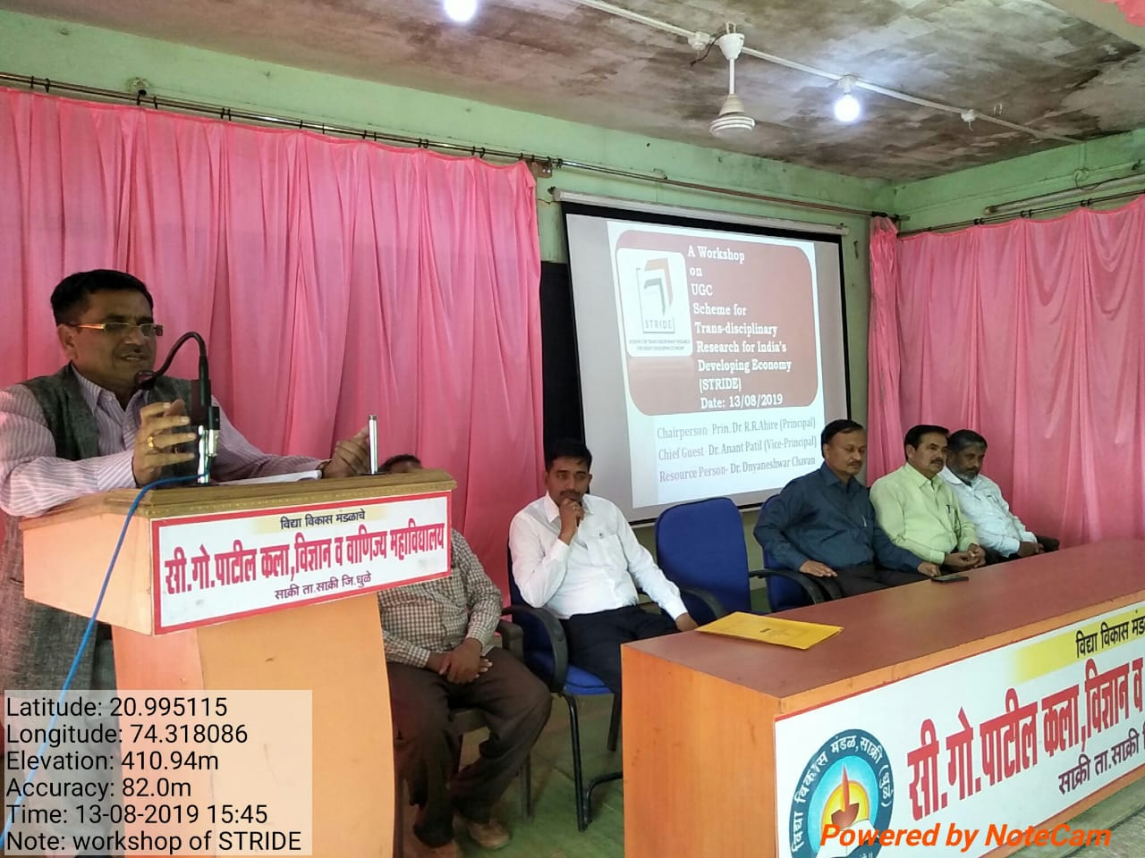

Prin. Dr. R.R. Ahire presenting his Inaugural Speech at the Workshop
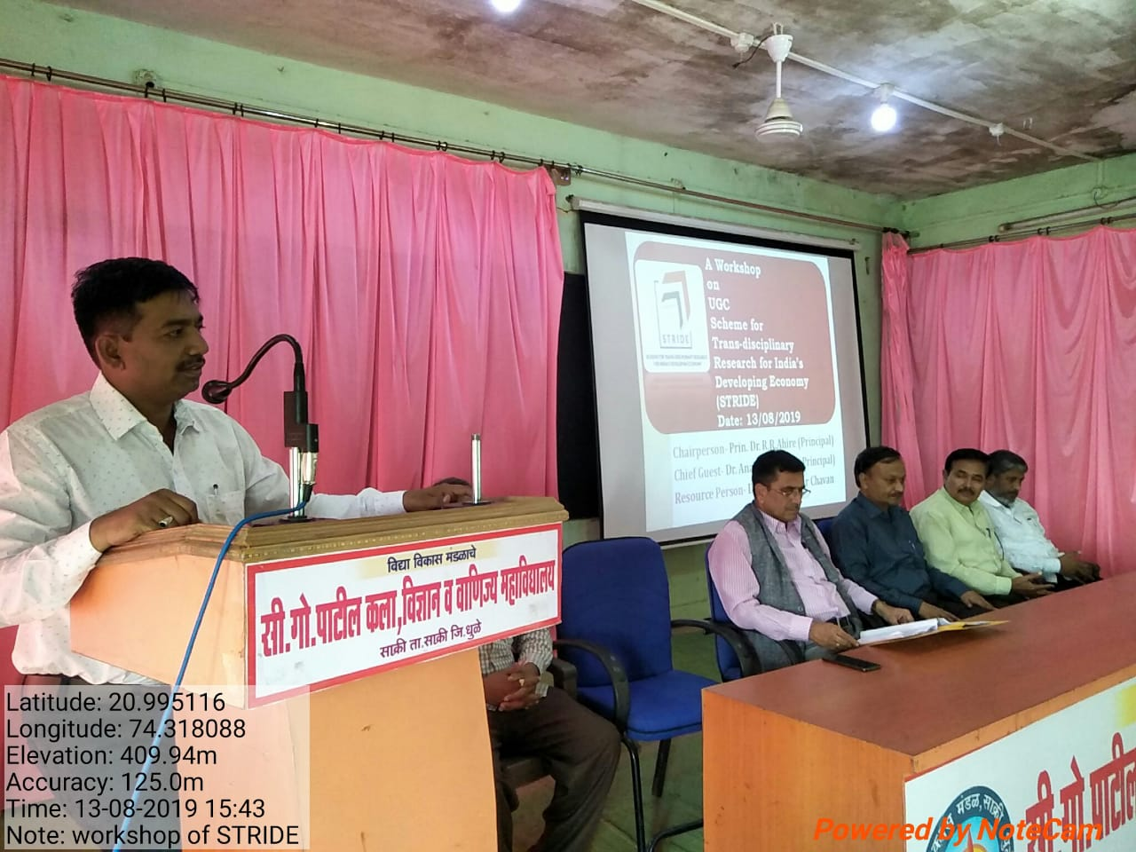

Dr. Dnyaneshwar Chavan (Coordinator) conducting a session

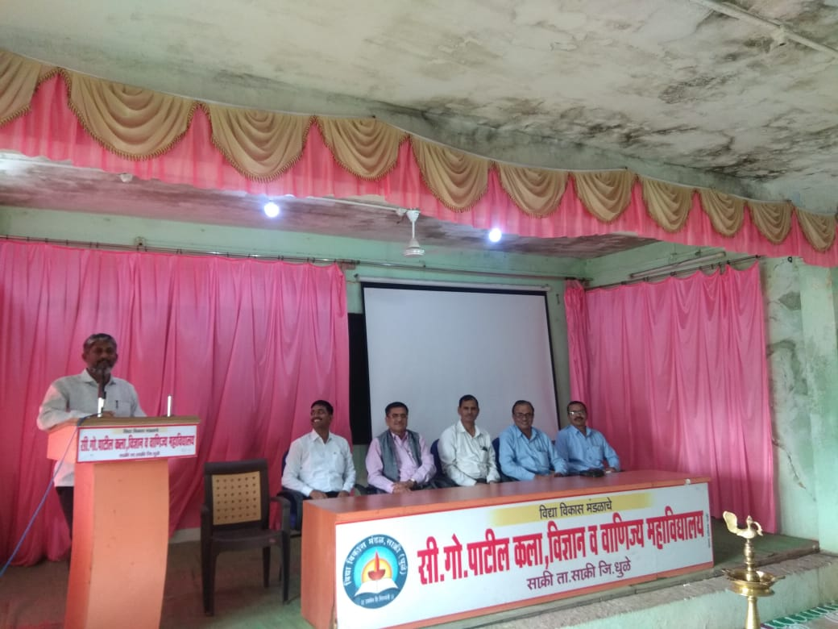

Dr. Sachin Nandre (Uttamrao Patil College, Dahiwel) presenting his views regarding the organization of the Workshop

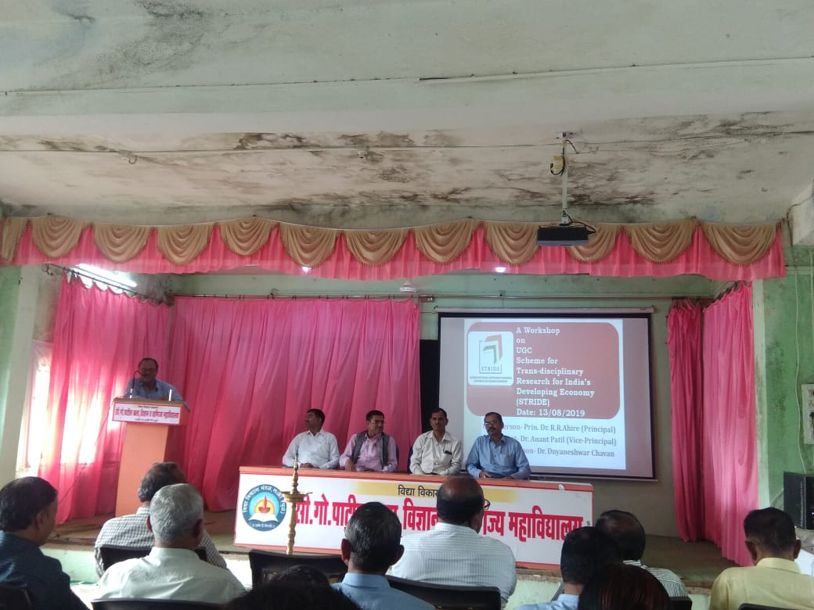
Prof. Walmik Shirsath (Karm. A. M. Patil College, Pimpalner) presenting his views regarding the organization of the Workshop

Media Coverage

